 |  | 

Fastlink DSL

Thank you for choosing Fast Link DSL provided by our affiliate, Intelleq Communications.

This packet will assist you with your system configuration to get you online as soon as possible.

Inside you will find setup guides for various versions of Windows and common email packages. Follow our easy step-by-step instructions enclosed and you should be online in no time.

INDEX

Setting up Windows 95/98/ME ………………………………………………………. 2
Setting up Windows XP ………………………………………………………………. 4
Setting up Outlook Express for the first time ………………………………………. 7
Changing Outlook Express Settings ………………………………………………… 10
Webmail ………………………………………………………………………………… 12
Personalized Home Page ……………………………………………………………. 13
Release/Renew your Systems IP Address …………………………………………. 14

As always if you have any questions feel free to call our Help Desk at 391-HELP(4357).

Windows 95/98/ME Configuration

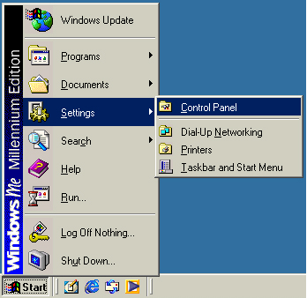 | From the Windows Desktop screen:  - Click the Start button.  - Move the mouse to Settings and click Control Panel.

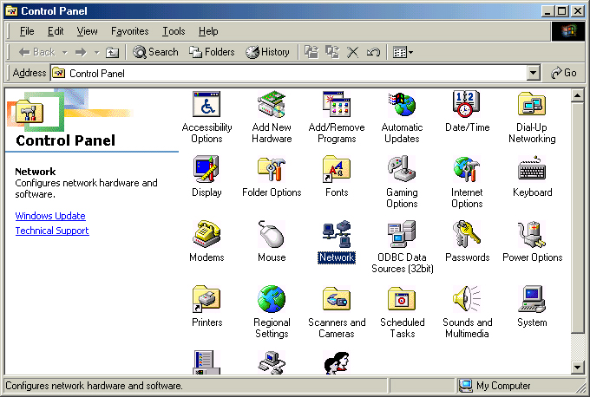 | - Double-click the icon marked Network.

You should receive this screen:

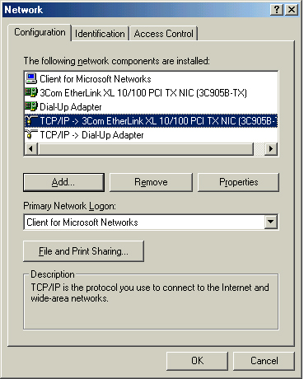 | - Left-click one time and highlight the TCP-IP -> (your network adapter).  - Click the button Properties.

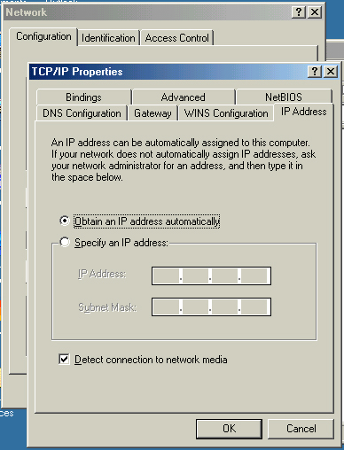 | - Verify that the line Obtain and IP address automatically is selected.  - Click the OK button on this window.  - Click the OK button on the previous window  If your computer asks for the Windows disk, go ahead and insert it. If it copies files let it complete and reboot the computer when prompted to do so.

Windows XP Configuration

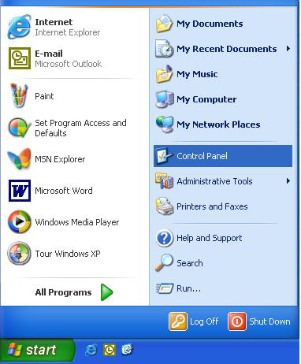 | From the Windows Desktop screen:  - Click the Start button.  - Click the Control Panel option.

You should see a screen like this one.

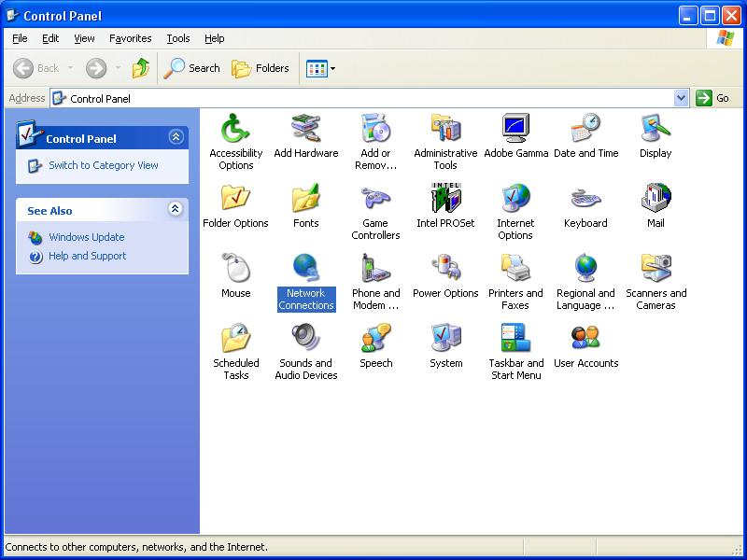 | - Double-click the option marked Network Connections

You should receive this screen.

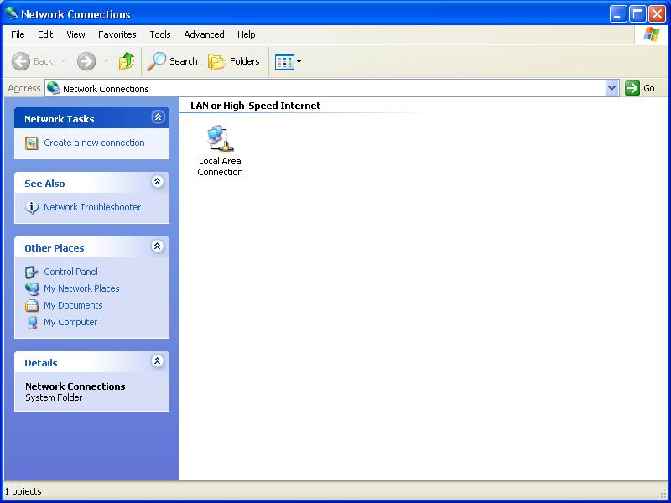 | - 4. Right-click one time on the Local Area Connection and select Properties.
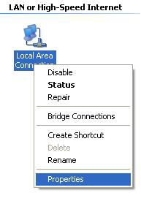

When you click Properties, a screen similar to this should appear.

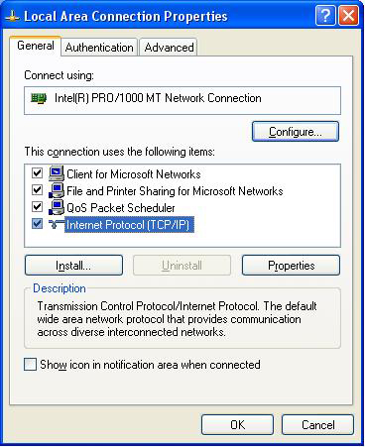 | 5. Highlight Internet Protocol (TCP/IP) by left-clicking one time on it.  6. Then click the Properties button

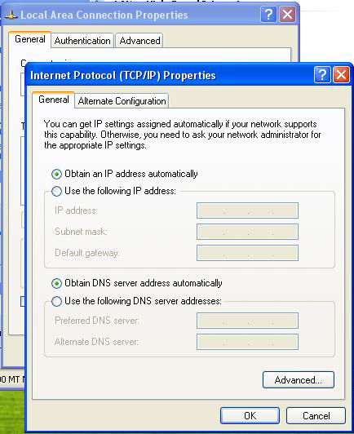 | Make sure you have the dot next to Obtain an IP address automatically and also Obtain DNS server address automatically.  7. Click the OK button at the bottom of this window,  8. Then click the OK button at the bottom of the previous window.

Setting up Outlook Express for the first time

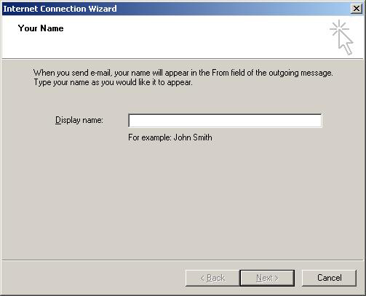 | When you start Outlook Express for the first time you should see a window like this one:  - Fill in the name that you want shown when you send email. This is the full name of the person that will primarily send email from this account..  - Once you have done this click Next.

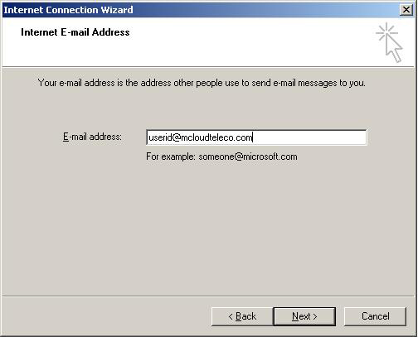 | - Fill in the full email address of the account that you will be checking mail for.  - Once you have done that click Next.

You should now see this screen:

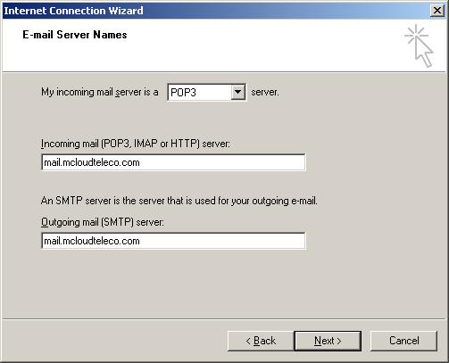 | On this screen we need to fill in the incoming (POP3) and outgoing (SMTP) mail server for your account.  - Make sure that the first line marked My incoming mail server is a is set to POP3 sever.  - In the field marked Incoming mail (POP3, IMAP or HTTP) server: put mail.mcloudteleco.com.  - Then in the field marked Outgoing mail (SMTP) server: put mail.mcloudteleco.com.  - Once you have done this click Next.

You should now see this screen:

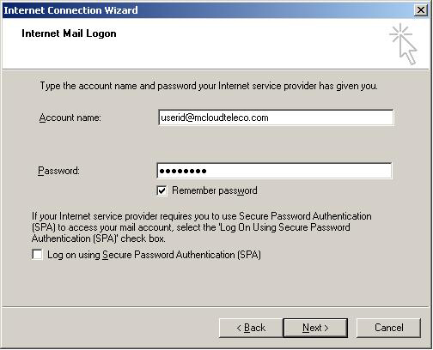 | On this screen you need to input your username and password for your mail account.  Please make sure that you type the account name and password accurately as usually when email doesn’t work it is due to the account name and/or password being typed incorrectly.  - Click in the Account name box and type the logon name.  - Click in the Password box and type the password for that account.  If you check the Remember Password box now you won’t have to enter it each time you go to check your mail. If you uncheck it then you would have to do that each time you check your mail.  Make sure that the box marked Log on using Secure Password Authentication (SPA) is NOT checked.  - Once you have done all of this please click Next.

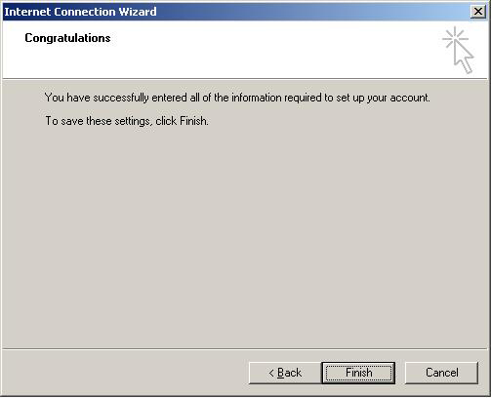 | 12. Just click on the Finish button and that’s it.  You should now be able to send and receive mail. If you are not then please go through your settings and make sure they are correct. If after doing that you still can not send or receive mail, please contact the Help Desk for assistance.

Changing Outlook Express Settings

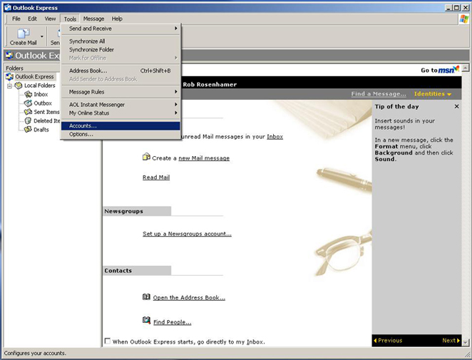 | - Open Outlook and click Tools in the menu and then Accounts.

You should see this screen:

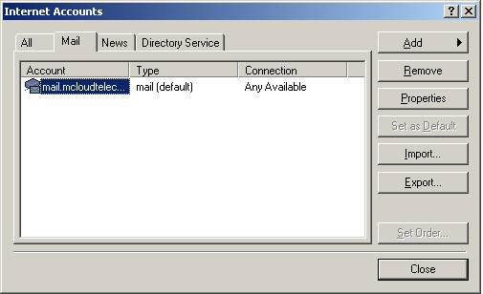 | - Click the Mail tab and make sure that your mail profile is highlighted then click Properties.

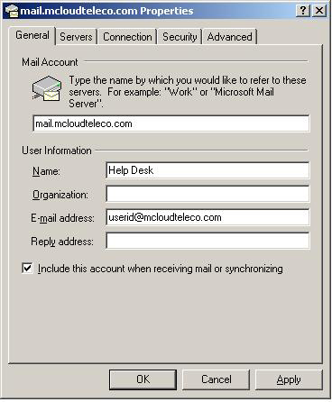 | - Verify that your Name is correct.  Organization really only needs to be filled in if you have a company name.  - Make sure that your full e-mail address is in the E-mail address field.  - Once you have done this click the tab marked Servers.
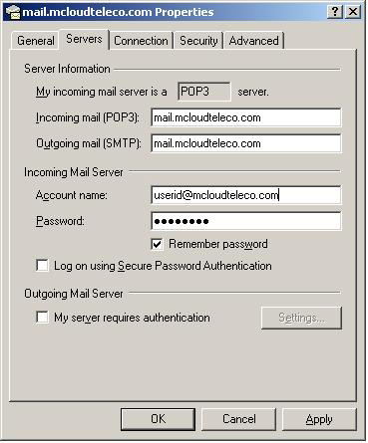 |  | - Verify that the server names are entered correctly.  Incoming mail (POP3) should be mail.mcloudteleco.com  Outgoing mail (SMTP) should be mail.mcloudteleco.com  - Also make sure that your Account name and Password are entered correctly.  - Once you have verified and changed information as needed, click the Apply button and then the OK button.  - Click Close on the next screen and you should be back at the main window for Outlook Express.  - To test the settings click the button at the top marked Send/Recv. If you get any errors just follow the steps again to re-verify the information.

Webmail

Webmail is accessible to you 24 hours a day, 7 days a week to check your email from any location. You may reach our webmail by visiting http://webmail.mcloudteleco.com

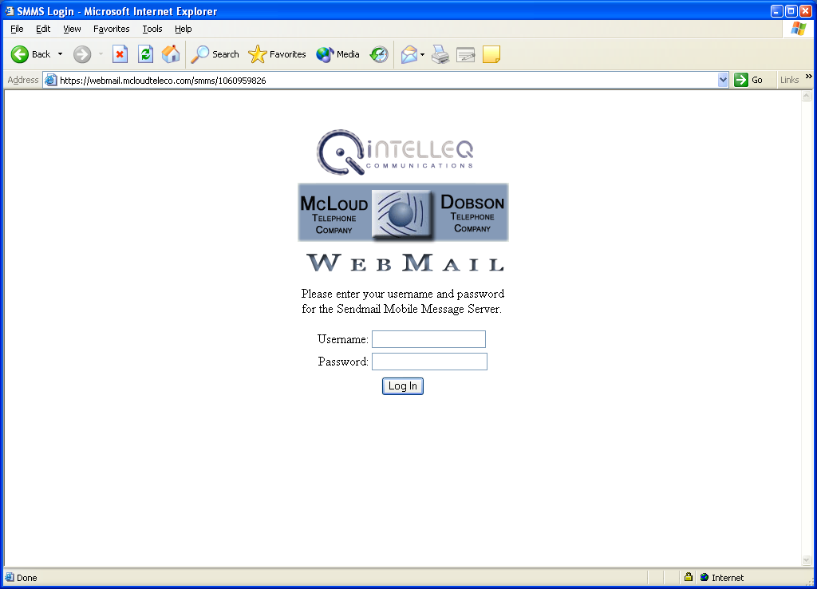

- Enter your full email address in the username field: (Example: user@mcloudteleco.com)
- Enter your email password and click Log In!

Personalized Home Page

Intelleq is pleased to introduce to you a new personalized home page that you may visit to read all the local news, look at stock quotes or even do some online shopping. To access your personalized home page visit http://myhome.intelleqcom.net

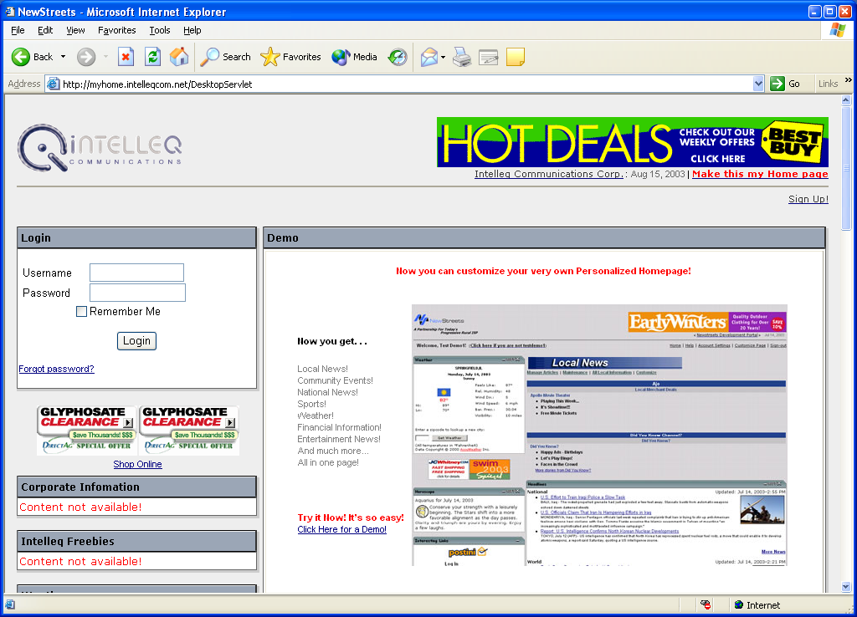

- Click Sign Up! In the upper right corner and complete the sign up page. This will allow you to create your login to the page.
- Once you have your login, enter your username and password in the Login Box and Click Login.
- Explore this site and opportunities that are in this new page and customize it to your own preference using the edit buttons found in each channel heading. Be sure to visit this site often for specials, the latest news and other information .

Release/Renew Your Systems IP Address

Windows 95/98

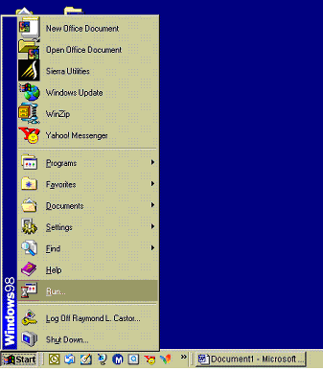  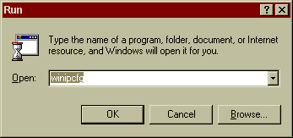 | - Click the Start button  - Move the Mouse to Run and Click on Run.  - Type winipcfg in the open box  - Click OK
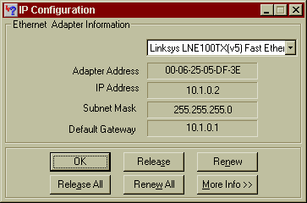 | - Click the Release All Button to release your IP Address  - Click the Renew All Button to renew your system IP Address.

Windows 2000/XP

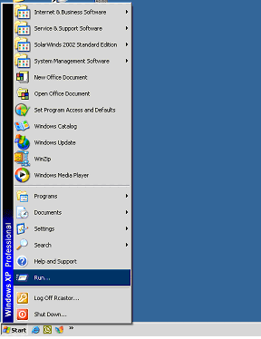  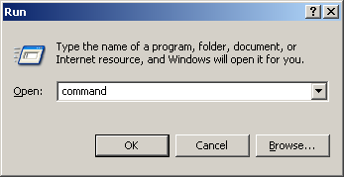 | - Click the Start button  - Move the Mouse to Run and Click on Run.  - Type command in the open box  - Click OK
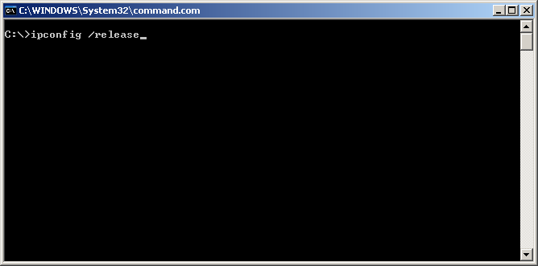 | - Type ipconfig /release  - Hit Enter

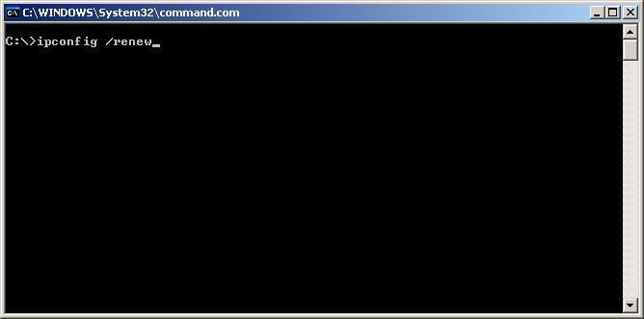 | - Type ipconfig /renew  - Hit Enter

